**BUG REPORT**

Designed by :Redhul K R

Date:27/01/2025

| **Platform** | **Browser** |
| --- | --- |
| Windows 12 | Chrome |

| **Who Detected** | **How Detected** | **Status** |
| --- | --- | --- |
| Quality Assurance | Testing | Open |

| **Founder** | **Bug ID** | **Type** | **Feature** | **Description** | **Steps** |
| --- | --- | --- | --- | --- | --- |
| Redhul | BUG_001 | Bug | Login | An invalid phone number is provided,but there is no error message. | 1. Visit the URL :<https://seller.bharatgo.com/login>  2.Type the invalid phone number  3. Click on the Get started button and verify user is able to login |
| Redhul | BUG_002 | Bug | Store details updation | The address for the store is not set even though the user gave the correct address | In the search bar type the street name and set as the location |
| Redhul | BUG_003 | Bug | Store details updation | The user was unable to gave the PIN Code and everything using GPS | Click on the use current location button and set the address of the location |

**Attachments**

**BUG ID:BUG_001**

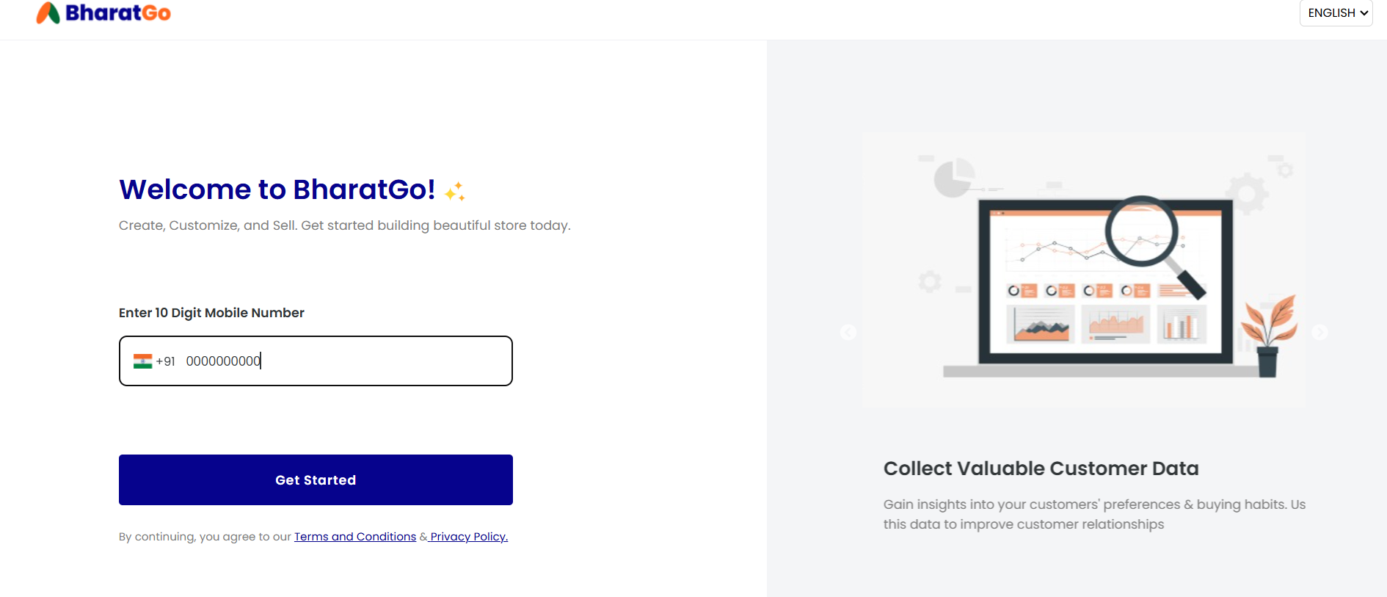

**BUG ID:BUG_002**

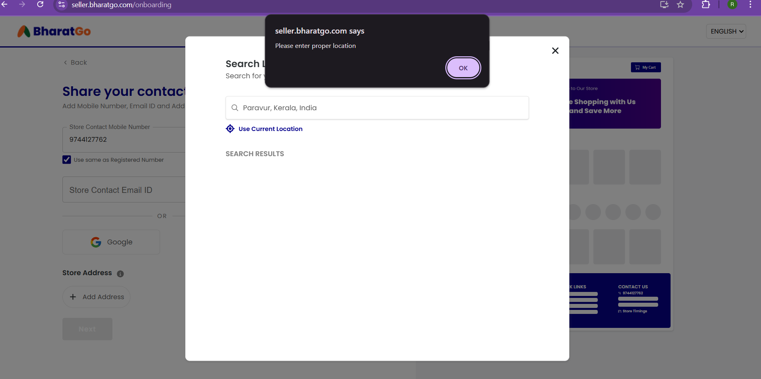

**BUG ID:BUG_003**

